1. Creating and Renaming Files/Directories
Create a directory named test_dir using mkdir.
Inside test_dir, create an empty file called example.txt.
Rename example.txt to renamed_example.txt using mv
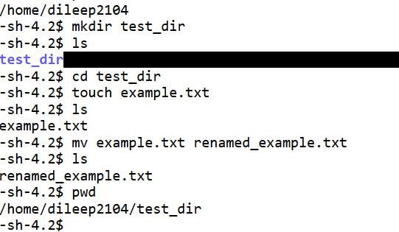

2. Viewing File Contents
Use cat to display the contents of /etc/passwd.
Cat /etc/paswd
Display only the first 5 lines of /etc/passwd using head.
Head -n 5 /etc/passwd
Display only the last 5 lines of /etc/passwd using tail.
Tail -n 5 /etc/passwd
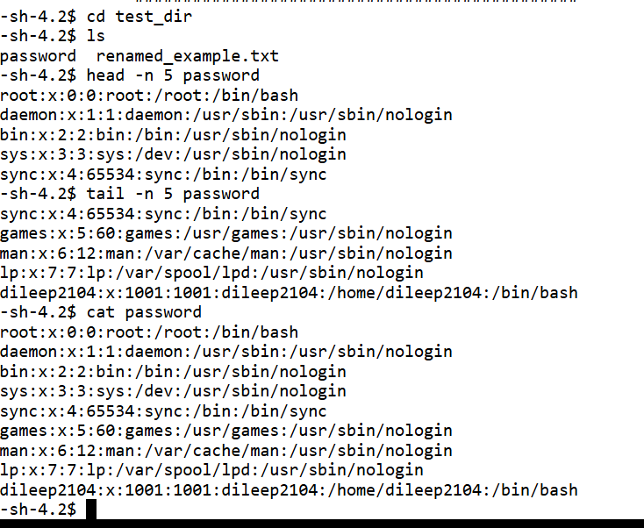

3.Searching for Patterns
Use grep to find all lines containing the word "root" in /etc/passwd.
Grep root /etc/passwd
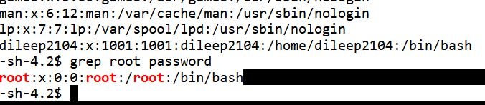

4. Zipping and Unzipping
Compress the test_dir directory into a file named test_dir.zip using zip.
Unzip test_dir.zip into a new directory named unzipped_dir.
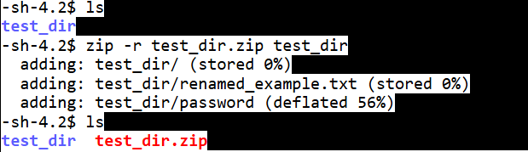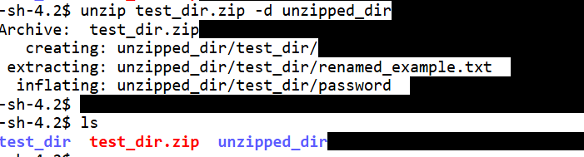

5. Downloading Files
Use wget to download a file from a URL (e.g., https://example.com/sample.txt).
wget https://www.w3.org/TR/PNG/iso_8859-1.txt
this will download iso_8859-1.txt

6. Changing Permissions
Create a file named secure.txt and change its permissions to read-only for everyone using chmod.
we can change the permissions
chmod 444 iso_8859-1.txt

7. Working with Environment Variables
Use export to set a new environment variable called MY_VAR with the value "Hello, Linux!".
export MY_VAR =”Hello Linux!”
echo $MY_VAR
Hello Linux!
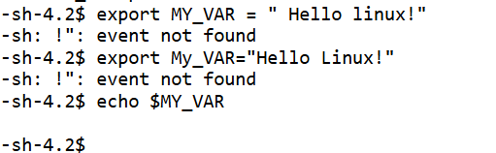

Submission Guidelines -: Attach Screenshots or command along with explanation and submit in doc(google doc or microsoft doc) format also attach github repo link

Git Hub Link:

https://github.com/dileepdamera2104/Devops/tree/9b202e6f1e143308142eaec1689fd3d29560baa2/Tutedude

Note:
HI Sir,

I’m currently practicing on an online platform where certain commands are restricted due to environment limitations. I’ve provided my explanation along with a screenshot from the terminal to support my work.

